

Topic test 2
Name: __________________________________

Chapter 4: Functions and graphs

• Time allowed: 45 minutes
• CAS calculators may be used.
• Part A: 5 multiple-choice questions (5 marks)
• Part B: 7 short answer questions (57 marks)
• Part C: 2 analysis questions (14 marks)
Part A
5 multiple-choice questions
1 mark each: 5 marks
Circle the correct answer.
1 Which of the following is an even function?
A f(x) = 2x2 − 3x + 1
B f(x) = x4 − 7x
C f(x) = x4 − 7x2
D f(x) = x3 + 4x
E y = x4 + x3 − 3

[1 mark]
2 For the function f(x) = 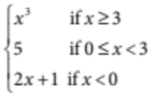 evaluate f(3) − f(2) − f(−1).
A 1
B 21
C −1
D 23
E 5
[1 mark]
3 Find the equation of the function that is 5 units to the left of y = x2 and 1 unit down.
A y = (x + 5)2 − 1
B y = (x + 5)2 + 1
C y = (x − 5)2 + 1
D y = 5x2 − 1
E y = (x − 5)2 − 1

[1 mark]
4 Find the domain and range of y = 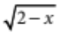.
A Domain {x: all real x}, range {y: all real y}
B Domain {x: all real x ≥ 2}, range {y: all real y ≥ 0}
C Domain {x: all real x ≠ 2}, range {y: all real y ≥ 0}
D Domain {x: all real x ≤ 2}, range {y: all real y ≥ 0}
E Domain {x: all real x ≥ 2}, range {y: all real y ≤ 0}

[1 mark]
5 Which graph is not a function?
A 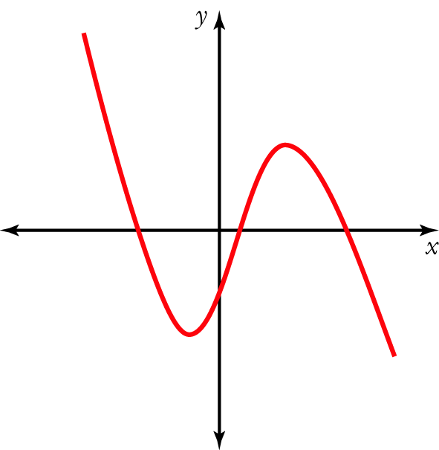 B 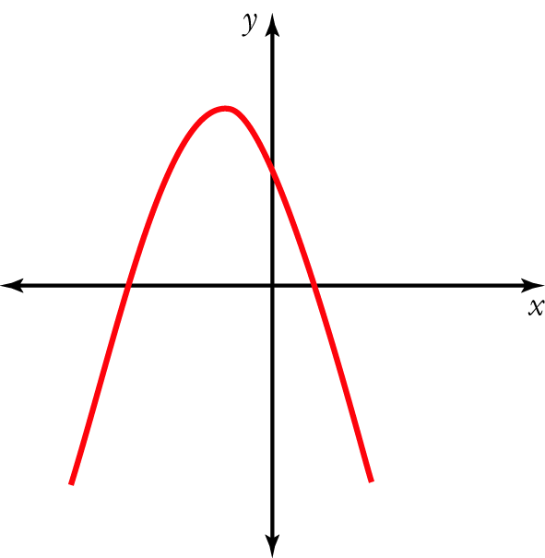 C 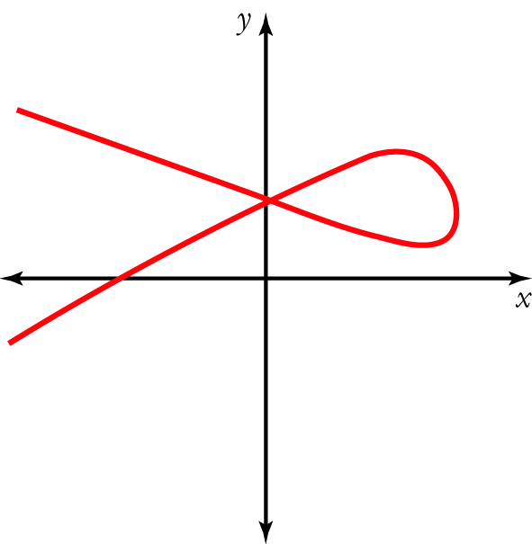

D 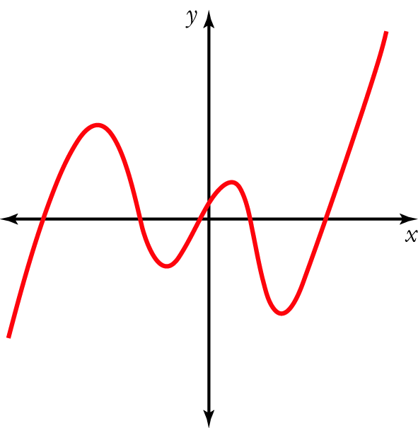 E 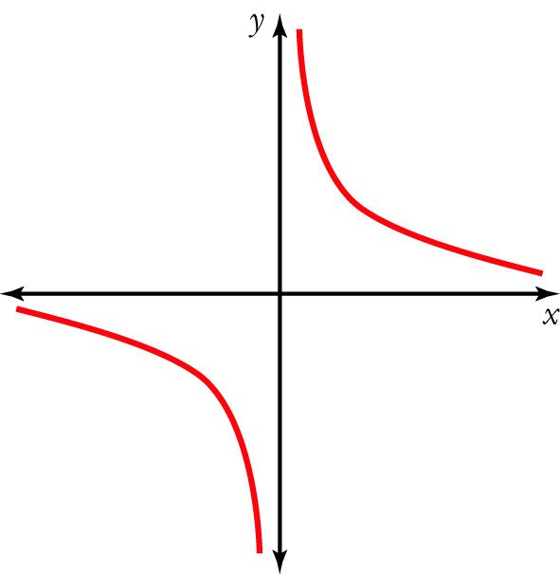
[1 mark]
Part B
7 short answer questions
57 marks
Show your working where appropriate.
1 Sketch the following graphs.
a y = 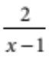 b x2 − 2x + y2 + 2y + 1= 0
c f(x) = (x − 1)3 d x = −3
e f(x) = x2 + 3x [10 marks]
2 Find the gradient of each of the following lines.
a with x-intercept of 1 and y-intercept of 4

b that makes an angle of 60° with the positive x-axis (exact value)

c perpendicular to the line x − 5y − 3 = 0

d passing through points (−7, 6) and (4, −3)

[9 marks]
3 Find the equations of the following.
a The line parallel to the line y = 3x + 1 that passes through (−1, 6).

b The quadratic function passing through (0, 1), (3, 4) and (1, −2).

c The circle with centre (2, −2) and radius 4.

[10 marks]
4 For the quadrilateral ABCD with vertices A = (−1, 0), B = (2, 4), C = (7, 4) and D = (4, 0):
a show that ABCD is a rhombus

b show that the diagonals AC and BD bisect each other.

[8 marks]
5 For the function y = −3x2 + x − 4:
a find the discriminant and state the number and type of its zeros

b find the equation of its axis of symmetry

c find the coordinates of its turning point and state whether it is a maximum or minimum

d sketch the graph of the function showing the axis, turning point and any intercepts.

[8 marks]
6 For P(x) = a(x − b)(x − c)(x − d):
a how many zeros does the function have, and what are they?

b what is the degree of the polynomial?

c if P(x) is a monic polynomial with b = 2, c = −1 and d = 4, sketch P(x).

[6 marks]
7 For the graph below, do the following.
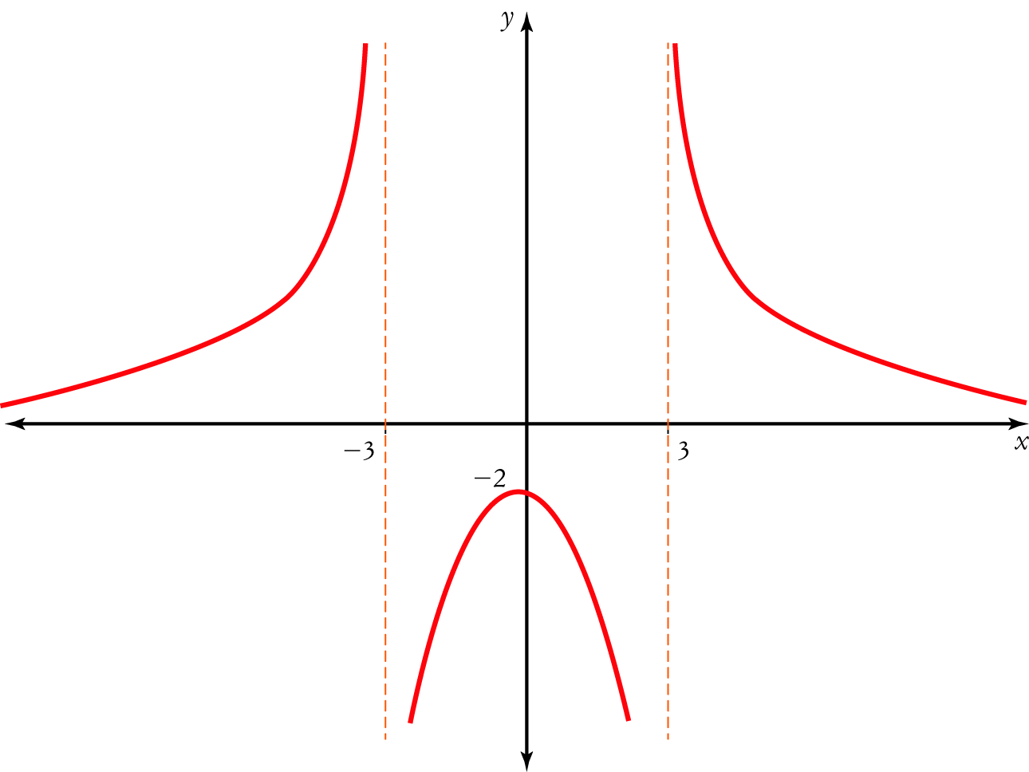
a State where the graph is discontinuous.

b Is the graph a function? __________________________________________________________
c State the domain over which the graph:
i has a positive gradient ________________________________________________
ii has a negative gradient ________________________________________________
iii is increasing ________________________________________________
iv is decreasing. ________________________________________________
[6 marks]
Part C
2 analysis questions
14 marks
Show your working where appropriate.
1 For the relation y2 = 4ax:
a state two functions that make up this relation.
________________________ ________________________
b draw a graph showing the general shape of this relation when a > 0.

c show that the point Q(aq2, 2aq) lies on the graph of y2 = 4ax.

d show that the gradient of line PQ, where P = (ap2, 2ap), is given by m 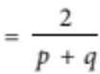

e show that the equation of PQ is given by 2x − (p + q)y + 2apq = 0.

[9 marks]
2 a Sketch the graphs of y = 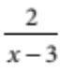 and y = 1 on the same set of axes.

b Use your graph to solve 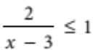.

[5 marks]
Total marks: 76
Answers
Part A [1 mark each]
1 A f(−x) = 2(−x)2 − 3(−x) + 1 = 2x2 + 3x + 1 ≠ f(x)
B f(−x) = (−x)4 − 7(−x) = x4 + 7x ≠ f(x)
C f(−x) = (−x)4 − 7(−x)2 = x4 − 7x2 = f(x), so the function is even.
D f(−x) = (−x)3 + 4(−x) = −x3 − 4x ≠ f(x)
E f(−x) = (−x)4 + (−x)3 − 3 = x4 − x3 − 3 ≠ f(x)
C [1 mark]
2 f (3) − f(2) − f(−1) = 33 − 5 − [2  (−1) + 1]
= 27 − 5 + 1
= 23
D [1 mark]
3 The function 5 units to the left of y = x2 is y = (x + 5)2.
The function 1 unit down from y = x2 is y = x2 − 1.
The function 5 units to the left of y = x2 and 1 unit down is y = (x + 5)2 − 1
A [1 mark]
4 For y =
2 − x ≥ 0
2 ≥ x
y ≥ 0
D [1 mark]
5 A 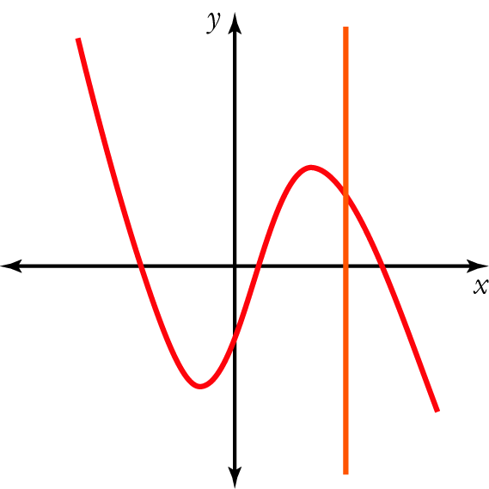 B 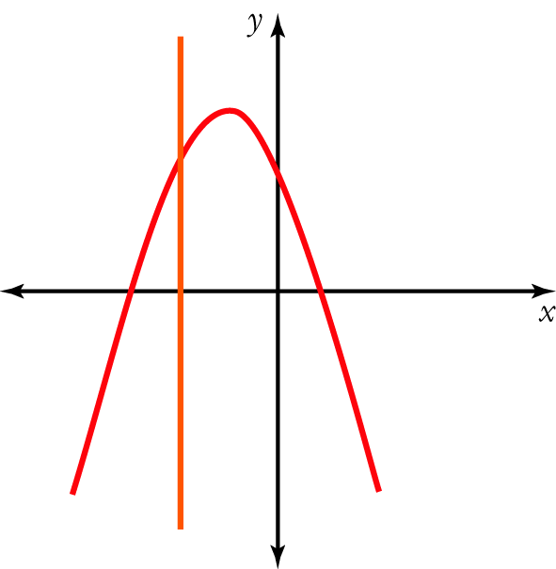

C 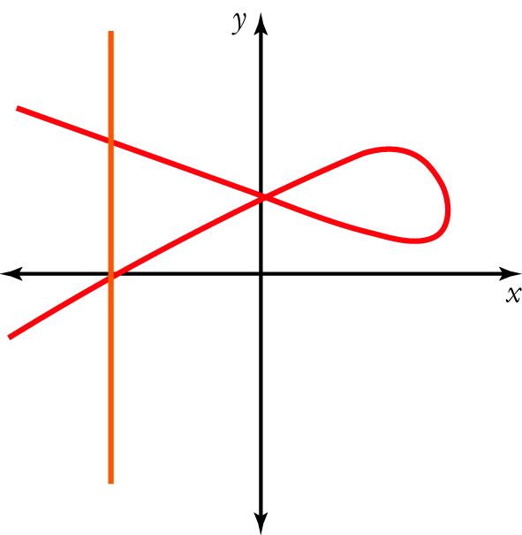 D 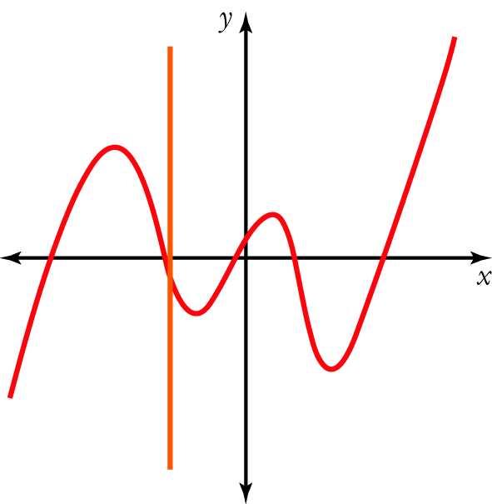
E 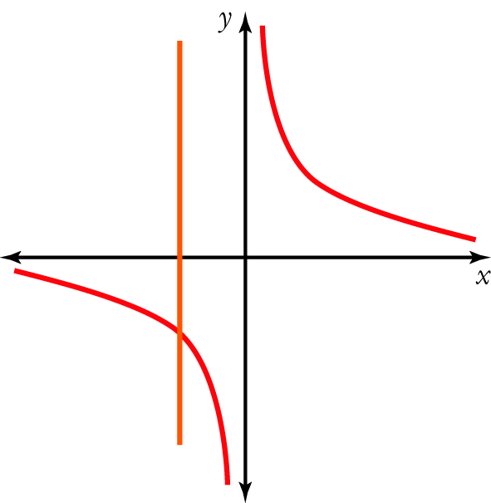
The vertical line crosses graph C in more than one place so it is not a function.
C [1 mark]
Part B
1 a This is a hyperbola in the 1st and 3rd quadrants with asymptotes at x = 1 and y = 0.
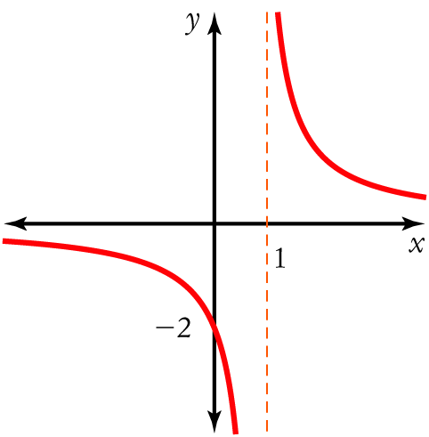
[2 marks]
b x2 − 2x + y2 + 2y = −1
x2 − 2x + 1 + y2 + 2y + 1 = −1 + 1 + 1
(x − 1)2 + (y + 1)2 = 1
This is a circle with centre (1, −1) and radius 1 unit. [2 marks]
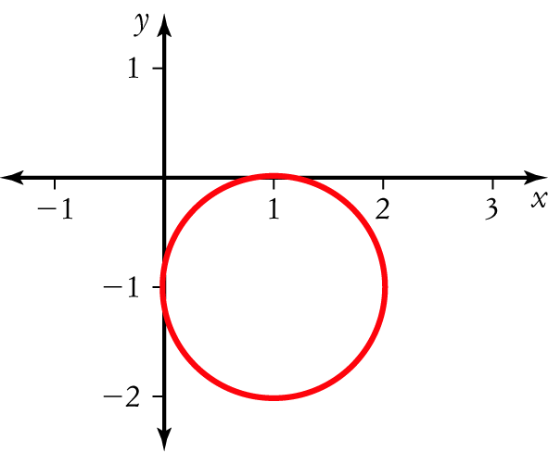
[1 mark]
c This is a cubic function translated horizontally 1 unit to the right.
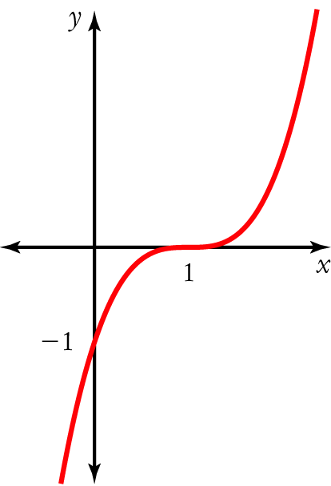
[2 marks]
d This is a vertical line passing through (−3, 0).
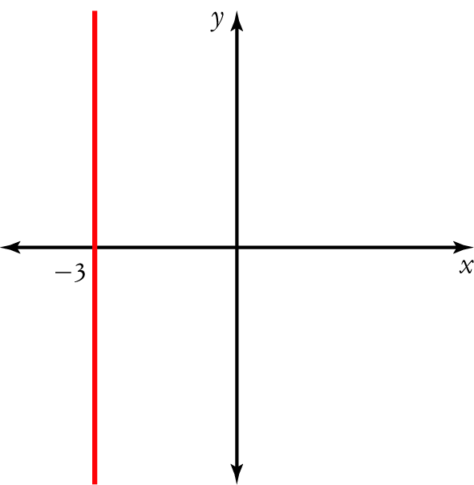
[1 mark]
e This is a parabola with x-intercepts when y = 0
x2 + 3x = 0
x(x + 3) = 0
x = 0 x + 3 = 0
x = 0 x = −3
For the y-intercept, x = 0
f(0) = 02 + 3(0) = 0
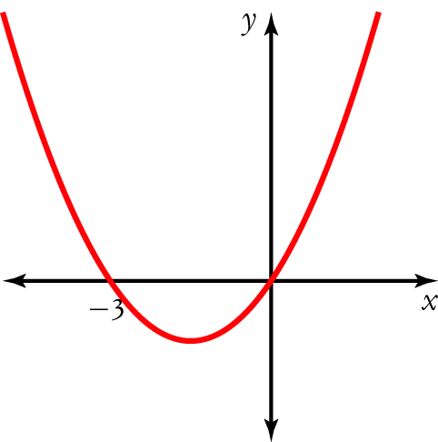
[2 marks]
2 a Substitute (1, 0) and (0, 4) into 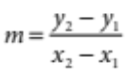 [1 mark]
m = 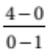 = −4 [1 mark]
b Substitute 60° into m = tan (θ) [1 mark]
m = tan (60°) = 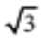 [1 mark]
c x − 5y − 3 = 0
x − 3 = 5y
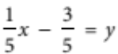 [1 mark]
m1 = [1 mark]
For perpendicular lines, m1m2 = −1
m2 = −5 [1 mark]
d Substitute (−7, 6) and (4, −3) into 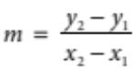 [1 mark]
m = 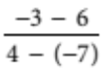 = −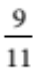 [1 mark]
3 a y = 3x + 1 has m1 = 3
For parallel lines, m1 = m2
m2 = 3 [1 mark]
Substitute m2 = 3 and (−1, 6) into y − y1 = m(x − x1)
y − 6 = 3[x − (−1)]
= 3(x + 1)
= 3x + 3
y = 3x + 9 [1 mark]
b General quadratic functions are in the form y = ax2 + bx + c
Substitute (0, 1).
1 = a(0)2 + b(0) + c
1 = c [1 mark]
Substitute (3, 4).
4 = a(3)2 + b(3) + c
= 9a + 3b + 1 (since c = 1)
3 = 9a + 3b
1 = 3a + b [1] [1 mark]

Substitute (1, −2).
−2 = a(1)2 + b(1) + c
= a + b + 1 (since c = 1)
−3 = a + b [2] [1 mark]
Solve simultaneous equations.
[1]–[2]:
4 = 2a
2 = a [1 mark]
Substitute a = 2 into [1].
1 = 3(2) + b
= 6 + b
−5 = b
The function’s equation is y = 2x2 − 5x + 1 [1 mark]
c Substitute (2, −2) and r = 4 into (x − a)2 + (y − b)2 = r2
(x − 2)2 + (y − (−2))2 = 42 [1 mark]
(x − 2)2 + (y + 2)2 = 16
x2 − 4x + 4 + y2 + 4y + 4 = 16 [1 mark]
x2 − 4x + y2 + 4y + 8 = 16
x2 − 4x + y2 + 4y − 8 = 0 [1 mark]
4 a Use 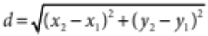 to find the length of each side.
AB = 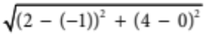
= 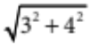
= 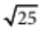
= 5 [1 mark]
BC = 5 (horizontal distance) [1 mark]
CD = 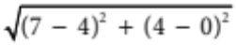
= 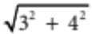
=
= 5 [1 mark]
AD = 5 (horizontal distance) [1 mark]
Since all sides are equal, ABCD is a rhombus. [1 mark]
b Use M = 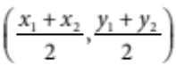 to find the midpoint of each diagonal.
Midpoint of AC = 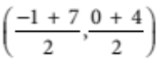
= (3, 2) [1 mark]
Midpoint of BD = 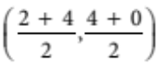
= (3, 2) [1 mark]
Since the midpoints are equal, the diagonals meet at the midpoint.
So the diagonals bisect each other. [1 mark]
5 a Δ = b2 − 4ac
= 12 − 4(−3)(−4)
= −47 [1 mark]
Since Δ < 0, there are no real zeros. [1 mark]
b x = 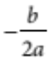
= 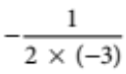 [1 mark]
=
The equation of the axis of symmetry is x = [1 mark]
c Substitute x = .
y = 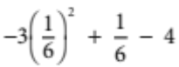
= 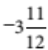
The turning point is 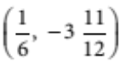. [1 mark]
It is a maximum since a < 0 (a = −3). [1 mark]
d No x-intercepts since Δ < 0.
For the y-intercept, x = 0
y = −3(0)2 + 0 − 4
= −4
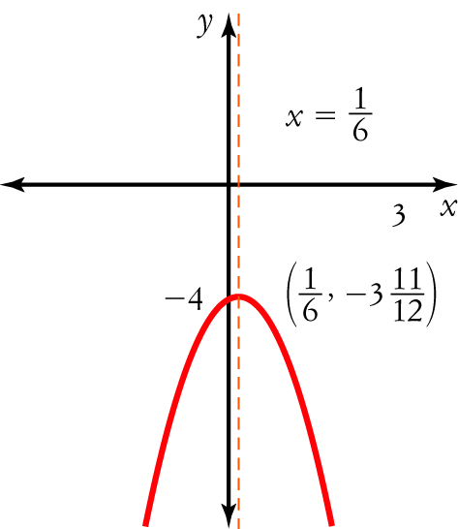
[2 marks]
6 a For zeros, P(x) = 0
a(x − b)(x − c)(x − d) = 0 [1 mark]
x − b = 0 x − c = 0 x − d = 0
x = b x = c x = d
There are 3 zeros at x = b, c, d [1 mark]
b The highest power of x is x3 (if you expand the brackets). So P(x) has degree 3. [1 mark]
c Monic: a = 1
Substitute b = 2, c = −1, d = 4
P(x) = (x − 2)(x + 1)(x − 4) [1 mark]
Zeros are x = 2, −1, 4 (from part a).
For x < −1: y < 0
For −1 < x < 2: y > 0
For 2 < x < 4: y < 0
For x > 4: y > 0
For the y-intercept, x = 0
y = (0 − 2)(0 + 1)(0 − 4) = 8
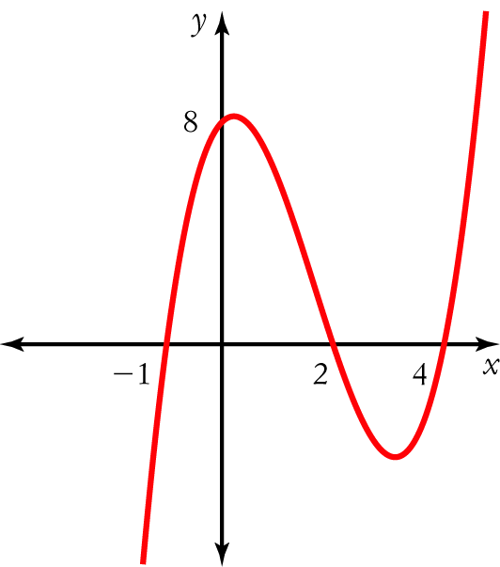 [2 marks]
7 a The graph is discontinuous at x =  3 (the asymptotes) [1 mark]
b The graph is a function (vertical line test) [1 mark]
c i The gradient is positive (rising) for {x: x < −3, −3 < x < 0} [1 mark]
ii The gradient is negative (falling) for {x: 0 < x < 3, x > 3} [1 mark]
iii The graph is increasing (rising) for {x: x < −3, −3 < x < 0} [1 mark]
iv The graph is decreasing (falling) for {x: 0 < x < 3, x > 3} [1 mark]
Part C
1 a y2 = 4ax
y = 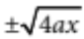
= 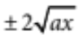
The 2 functions are y = 2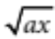and y = −2 [1 mark]
b ax ≥ 0 so x ≥ 0 (a > 0)
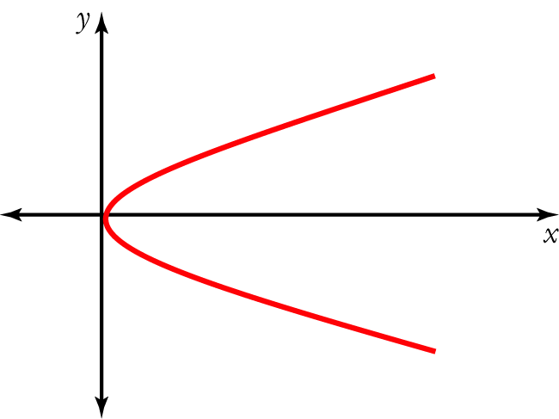
[2 marks]
c Substitute Q into the equation y2 = 4ax
LHS = y2
= (2aq)2
= 4a2q2
RHS = 4ax
= 4a(aq2)
= 4a2q2
Since LHS = RHS, point Q lies on y2 = 4ax [1 mark]
d Substitute P and Q into 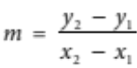
m 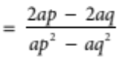 [1 mark]
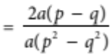
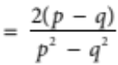
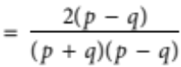
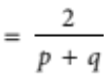 [1 mark]
e y − y1 = m(x − x1)
y − 2aq = 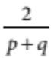 (x − aq2) [1 mark]
(p + q)(y − 2aq) = 2(x − aq2)
(p + q)y − (p + q)2aq = 2x − 2aq2
(p + q)y − 2apq − 2aq2 = 2x − 2aq2
Moving all terms to the RHS and simplifying, we have
0 = 2x − (p + q)y + 2apq [2 marks]
2 a y = is a hyperbola in the 1st and 3rd quadrants with asymptotes at x = 3 and y = 0.
y = 1 is a horizontal line with y-intercept 1.
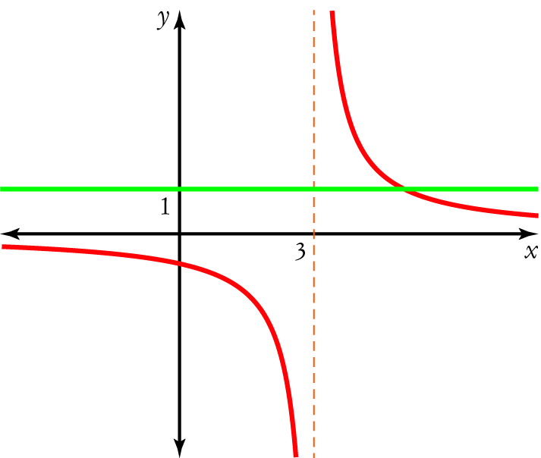
[3 marks]

b Graphically, 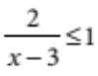 is the part of the graph 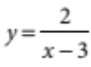 that is on and below the line y = 1.
Find the point of intersection of the graphs by substituting y = 1 into .
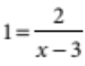
x − 3 = 2
x = 5 [1 mark]
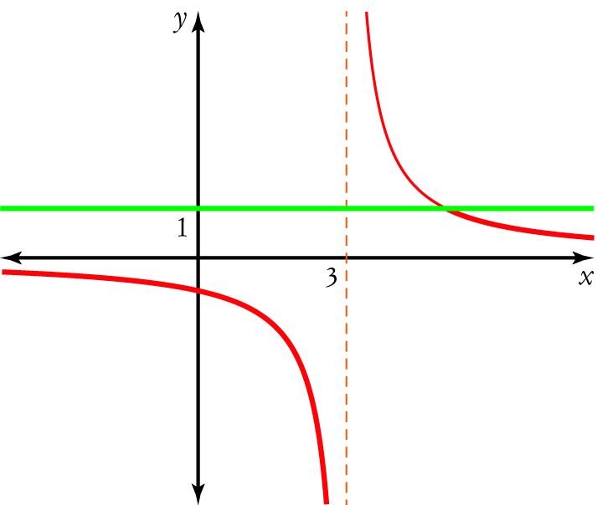
The solution is x < 3, x ≥ 5 [1 mark]
You could write this solution as when {x < 3}  {x ≥ 5}.

